WEEK 6

REACT

1. ReactJS-HOL

Create a new React Application with the name “myfirstreact”, Run the application to print “welcome to the first session of React” as heading of that page.

**Code:**

**App.js**

import React from 'react';

function App() {

return (

<div>

<h1>Welcome to the first session of React</h1>

</div>

);

}

export default App;

**Output:**

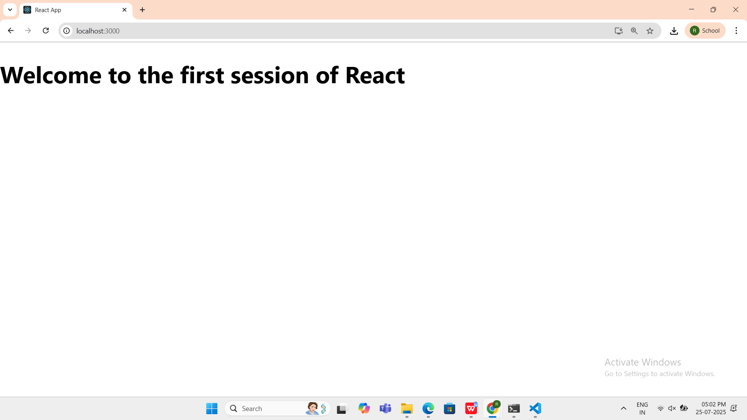

1. ReactJS-HOL

**Code:**

**Home.js**

import React from 'react';

function Home() {

return (

<div>

<h2>Welcome to the Home page of Student Management Portal</h2>

</div>

);

}

export default Home;

**About.js**

import React from 'react';

function About() {

return (

<div>

<h2>Welcome to the About page of the Student Management Portal</h2>

</div>

);

}

export default About;

**Contact.js**

import React from 'react';

function Contact() {

return (

<div>

<h2>Welcome to the Contact page of the Student Management Portal</h2>

</div>

);

}

export default Contact;

**App.js**

import React from 'react';

import Home from './Components/Home';

import About from './Components/About';

import Contact from './Components/Contact';

function App() {

return (

<div>

<h1>Student Management Portal</h1>

<Home />

<About />

<Contact />

</div>

);

}

export default App;

**Output:**

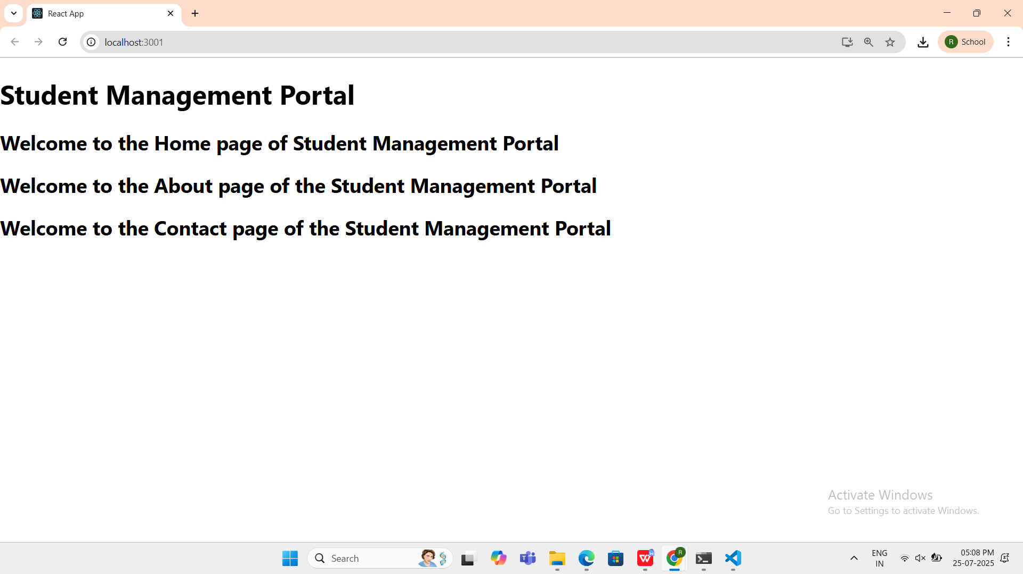

1. ReactJS-HOL

**CODE:**

**CalculateScore.js**

import '../Stylesheets/mystyle.css';

const percentToDecimal = (decimal) => {

return (decimal * 100).toFixed(2) + '%';

};

const calcScore = (total, goal) => {

return percentToDecimal(total / goal);

};

export const CalculateScore = ({ Name, School, total, goal }) => (

<div className="formatstyle">

<h1><font color="Brown">Student Details:</font></h1>

<div className="Name">

<b><span>Name: </span></b>

<span>{Name}</span>

</div>

<div className="School">

<b><span>School: </span></b>

<span>{School}</span>

</div>

<div className="Total">

<b><span>Total: </span></b>

<span>{total}</span> Marks

</div>

<div className="Score">

<b>Score: </b>

{calcScore(total, goal)}

</div>

</div>

);

**Mystyle.css**

.Name {

font-weight: 300;

color: blue;

}

.School {

color: crimson;

}

.Total {

color: darkmagenta;

}

.formatstyle {

text-align: center;

font-size: large;

}

.Score {

color: forestgreen;

}

**App.js**

import { CalculateScore } from './components/CalculateScore';

function App() {

return (

<div>

<CalculateScore

Name="Steeve"

School="DNV Public School"

total={284}

goal={300}

/>

</div>

);

}

export default App;

**OUTPUT:**

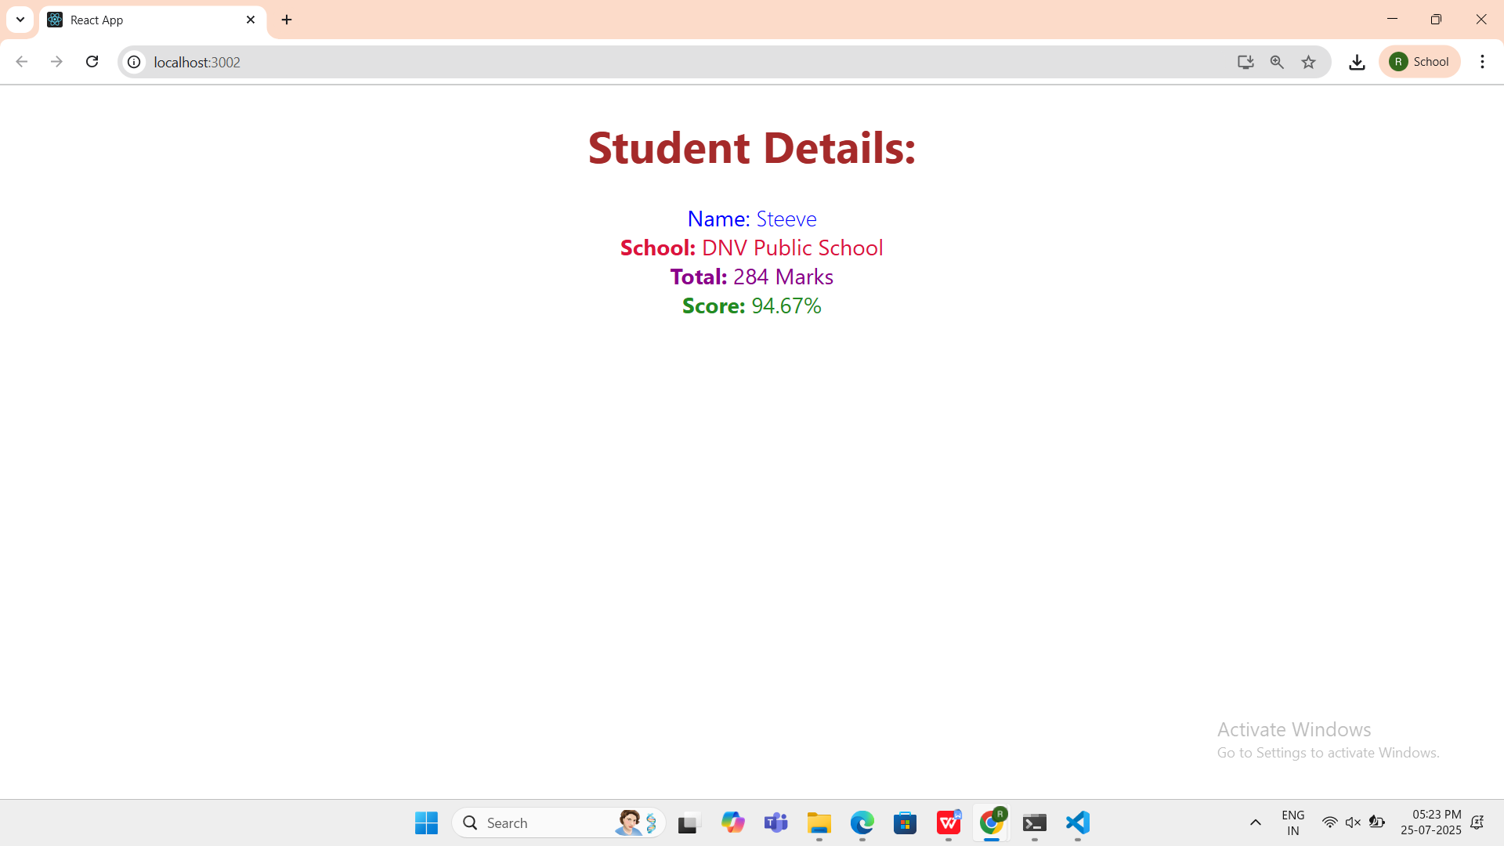

1. ReactJS-HOL

**CODE:**

**Post.js**

class Post {

  constructor(id, title, body) {

    this.id = id;

    this.title = title;

    this.body = body;

  }

}

export default Post;

**Posts.js**

import React, { Component } from 'react';

import Post from './Post';

class Posts extends Component {

  constructor(props) {

    super(props);

    this.state = {

      posts: []

    };

  }

  loadPosts = () => {

    fetch('https://jsonplaceholder.typicode.com/posts')

      .then((res) => res.json())

      .then((data) => {

        const postObjects = data.map((item) => new Post(item.id, item.title, item.body));

        this.setState({ posts: postObjects });

      })

      .catch((error) => {

        console.error('Error fetching posts:', error);

        throw error;

      });

  };

  componentDidMount() {

    this.loadPosts();

  }

  componentDidCatch(error, info) {

    alert('An error occurred: ' + error.message);

  }

  render() {

    return (

      <div>

        <h1>Blog Posts</h1>

        {this.state.posts.map((post) => (

          <div key={post.id}>

            <h3>{post.title}</h3>

            <p>{post.body}</p>

            <hr />

          </div>

        ))}

      </div>

    );

  }

}

export default Posts;

**App.js**

import React from 'react';

import Posts from './Posts';

function App() {

  return (

    <div className="App">

      <Posts />

    </div>

  );

}

export default App;

**OUTPUT:**

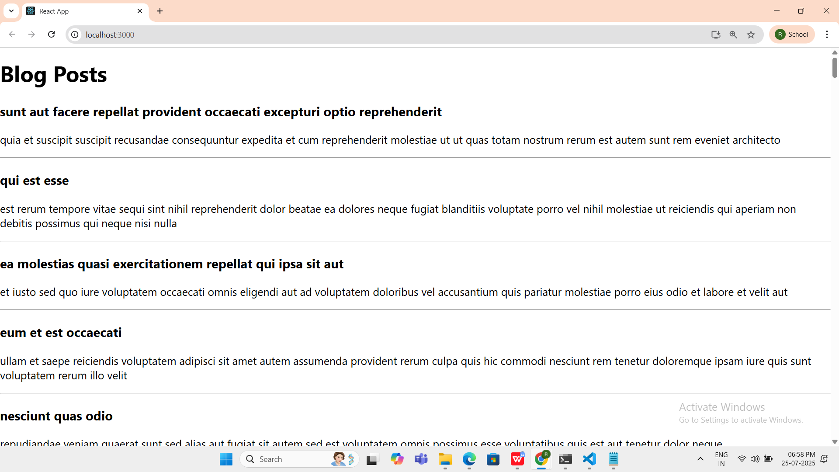

1. ReactJS-HOL

**CODE:**

**CohortDetails.module.css**

.box {

width: 300px;

display: inline-block;

margin: 10px;

padding: 10px 20px;

border: 1px solid black;

border-radius: 10px;

}

dt {

font-weight: 500;

}

**CohortDetails.js**

import React from 'react';

import styles from './CohortDetails.module.css';

const CohortDetails = ({ cohort }) => {

const headingStyle = {

color: cohort.status.toLowerCase() === 'ongoing' ? 'green' : 'blue',

};

return (

<div className={styles.box}>

<h3 style={headingStyle}>{cohort.name}</h3>

<dl>

<dt>Started On</dt>

<dd>{cohort.startDate}</dd>

<dt>Current Status</dt>

<dd>{cohort.status}</dd>

<dt>Coach</dt>

<dd>{cohort.coach}</dd>

<dt>Trainer</dt>

<dd>{cohort.trainer}</dd>

</dl>

</div>

);

};

export default CohortDetails;

**App.js**

import React from 'react';

import CohortDetails from './CohortDetails';

function App() {

const cohorts = [

{

name: 'INTADMDF10-.NET FSD',

startDate: '22-Feb-2022',

status: 'Scheduled',

coach: 'Aathma',

trainer: 'Jojo Jose',

},

{

name: 'ADM21JF014-Java FSD',

startDate: '10-Sep-2021',

status: 'Ongoing',

coach: 'Apoorv',

trainer: 'Elisa Smith',

},

{

name: 'CDBJF21025-Java FSD',

startDate: '24-Dec-2021',

status: 'Ongoing',

coach: 'Aathma',

trainer: 'John Doe',

},

];

return (

<div>

<h2>Cohorts Details</h2>

{cohorts.map((cohort, index) => (

<CohortDetails key={index} cohort={cohort} />

))}

</div>

);

}

export default App;

OUTPUT:

